Description of the project:

"Organization of small-scale production of energy-saving gas-discharge lamps with increased luminous intensity based on new technologies"

Relevance and novelty. The need for rational and efficient use of energy resources through the transition to sustainable development and economy of consumed energy determines the relevance of this development. The novelty of the innovation lies in the technology of adding nanoparticles, which improve the technical characteristics of fluorescent lamps.
Idea. A group of scientists from Al-Farabi KazNU conducted research to determine the effects of nanoparticles on plasma. The research results reveal that the addition of nanoparticles to the volume of the gas discharge (into the plasma) leads to an increase in the intensity of the discharge glow by more than one and a half times at equal powers. The discovered effect was proposed for use in gas-discharge fluorescent lamps to increase the luminous efficiency.
Thus, an innovative technology was developed to increase the glow intensity of gas-discharge lamps based on the addition of nanoparticles, and laboratory samples of a gas-discharge lamp with a high glow intensity were obtained (Figure 1).

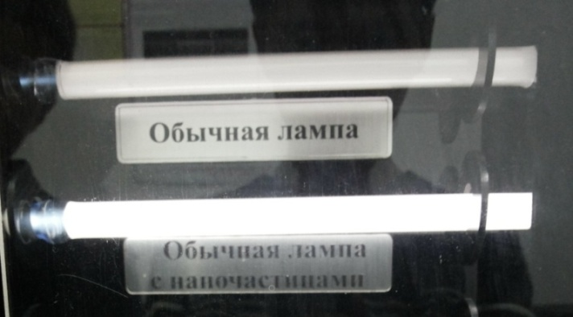

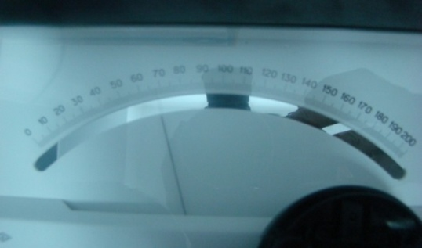

Figure 1 - test samples of gas discharge lamps

Figure 1 shows two gas-discharge lamps operating at absolutely identical electrical, geometric and gas parameters, with the only difference in the content of nanoparticles inside the second lamp. As can be seen from the figure, when using a gas-discharge lamp with nanoparticles, the light output is 2-3 times higher than in a conventional gas-discharge lamp.
This technology has no analogues in Kazakhstan, is protected by a patent of the Republic of Kazakhstan for an invention, and the samples of the developed energy-saving lamp passed all test tests and received a certificate of conformity (Figure 2, 3).

Figure 2 - Patent for invention Figure 3 - Certificate of conformity

Expected results: production volume of at least 100 000-150 000 units per year.
Consumers: wholesale buyers, in particular, resellers, construction stores, specialized retail stores of lighting equipment; retail buyers represented by various organizations, shopping centers, business centers, universities; state institutions.
Advantages. The presence of an innovative component of the proposed product, which provides a low cost price with high quality, is the main key to the competitiveness of the product. Main competitive advantages:
- Low cost with our own production line;
- High luminous efficiency, exceeding the indicator of incandescent lamps by 3 times, energy consumption is up to 7 times lower;
- Increase in luminescence intensity by more than one and a half times with the addition of nanoparticles in comparison with fluorescent lamps;
- Safety due to the minimum amount of mercury in the composition.
To date, the small-scale production – 50 000 units of T5 and T6 lamps have been manufactured. The weekly production capacity is 3000 lamp units.

