NON-PROFIT JOINT-STOCK COMPANY
«AL-FARABI KAZAKH NATIONAL UNIVERSITY»

FACULTY OF PHYSICS AND TECHNOLOGY

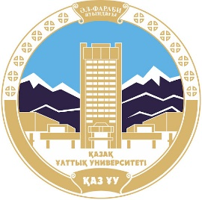 | 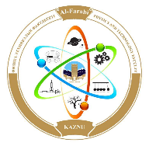 | 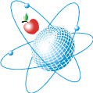 | 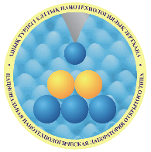

INFORMATION LETTER!
Dear colleagues!
Faculty of Physics and Technology of Al-Farabi Kazakh Natuinal University on April 4-7, 2022 is holding an international scientific online conference of students and young scientists «FARABI ALEMI». The conference is open to students, graduates and young scientists under 35 years all universities.

Directions of the conference work:
- Theoretical physics
Secretary: Komarov Andrey, komandr65@mail.ru, 87024047119
- Nuclear physics
Secretary: Nurbakyt Gulmira, gumi-nur@mail.ru, 87026363523
- Condensed matter physics and Nanomaterials Science
Secretary: Suyundykova Gulnur, section201803@gmail.com, 87005101079
- Thermophysics and Theoretical Heat Engineering
Secretary: Sultan Meirambek, meirambek.sultan@bk.ru, 87772158819
- Radio Physics and Electronics. Astronomy
Secretary: Ikramova Saltanat, section201805@gmail.com, 87476984280
- Energy and energy efficiency
Secretary: Zhumabaev Abdisattar, abusattar_93@mail.ru, 87752599010
- Standardization, Certification and Metrology
Secretary: Kaltay Tolganay, tolganaykaltay@gmail.com, 87071751650
- Plasma Physics and Nanotechnology
Secretary: Syzganbaeva Saule, Syzganbaeva.1@gmail.com, 87085296414
- Educational technologies in physics
Secretary: Moldabekov Zhangali, Alfarabi_conf@mail.ru , 87476576963

Conference languages: Kazakh, Russian and English.
The conference materials will be published in an electronic collection, which will be posted on the faculty website. Conference participants will receive certificates; the best scientific reports will be awarded with diplomas.

To participate in the Conference, participants from other cities must send, no later than February 20, 2022, a completed registration form, abstracts of reports and a recommendation of the scientific advisor, a certificate of originality of the work (from the website www.antiplagiat.ru or from the Univer system) by e-mail to the secretary of the selected section.
Students and young scientists of the Faculty of Physics and Technology submit a registration form, abstracts, a certificate of originality of the work (from the website www.antiplagiat.ru or from the Univer system) in electronic form to the secretaries of the selected section until February 20, 2022.

REQUIREMENTS FOR ABSTRACT PREPARATION
- The abstract should not exceed 1 page, Microsoft Word
- Name the location in the center (in capital letters, font bold, 12pt)
- Below the center is the author's surname and initials (lower case letters, boldface font, 11pt).
- Below in the center surname and initials, academic degree and title of supervisor (in lowercase letters, italics, bold, 11pt).
- Under the surname - the organization that you represent, the city, (in lower case letters, 11pt).
- Below is the email address (italic,10pt).
- Abstracts must be accompanied by a review of the supervisor to reflect the relevance, novelty, and the main result (graphics, tables, pictures).
- Page parameters: top margin - 2 cm, bottom margin - 2 cm, left - 3 cm, right - 1.5 cm, Times New Roman font, font size - 12pt, single line spacing; paragraph indentation - 1 cm; portrait orientation; without headers and footers and page setting; text is justified
- Design of literature by sample, font - 11pt.

The conference organizing committee reserves the right to reject reports submitted outside the main areas of the conference and publish abstracts that do not meet the above requirements. The organizing committee does not intend to edit the text of the abstracts. No more than three abstracts are accepted from one author. Abstracts that are not completed in accordance with the requirements will be returned to the authors.

Abstracts of reports should be checked for borrowings from open sources (plagiarism). The check is carried out using the Internet resource - www.antiplagiat.ru or by the scientific advisor through the Univer system (for students and young scientists of Al-Farabi KazNU). The degree of originality must be at least 75%.

ORGANIZING COMMITTEE
Chairman: prof. Davletov A.
Vice-Chair: associate prof. Lavrishev O., PhD Muratov M.
The secretaries of the Organizing Committee: SRWS chairman, associate prof. Manatbayev R., CYS chairman Ismailov D.V.
Members of the Organizing Committee: prof. Kodanova S., prof. Bolegenova S., prof. Abishev M., PhD Ibraimov M.

PROGRAM COMMITTEE
Chairman: PhD Issanova M.K.
Members of the Program Committee: prof. Askarova A., prof. Zhussupov M., prof. Zhanabayev Z., prof. Takibayev N., prof.. Arkhipov Yu., prof. Imambekov O., prof. Zhaksybekova K., prof. Burkova N., prof. Yushkov A., prof. Iliin A., prof. Prihodko O., prof. Dzhumagulova K., prof. Dzhunushaliev V., prof. Yar-Mukhamedova G.Sh., associate prof. Zhukeshov A.M., prof.. Abdullin Kh., associate prof. Aldiyarov A. associate prof. Dosbolayev M., associate prof. Nurgaliyeva K.
REGISTRATION FORM
Name, Surname
University
Position (student, graduate student)
Course, specialization
Title of the report
Authors
Supervisor
Specify the section in which you would like to participate

An example of a report
UDC 541.124

TECHNOLOGIES FOR DEVELOPING CRITICAL THINKING

Akhmetov B.K.
Supervisor: PhD, Associate Professor. Ivanova M. A.
Abay KazNPU, Almaty, Kazakhstan
e-mail: ahmet@mail.ru

Text of the report...............................................................................................[1].

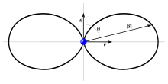
Fig. 1. - Radiation pattern of the dipole emitter in polar coordinates

References
1. Baalrud S., Daligault J. Contrib. Plasma Phys. – 2017. – Vol. 57. – p. 238–251.

